**Name:** Shivam Verma

**Course:** B.Sc. (H) Computer Science

**Semester:** 5th

**College Roll No.:** 19HCS4048

**Write programs in Python using NumPy library to do the following:**

1. **Compute the mean, standard deviation and variance of a two-dimensional random integer array along the second axis.**

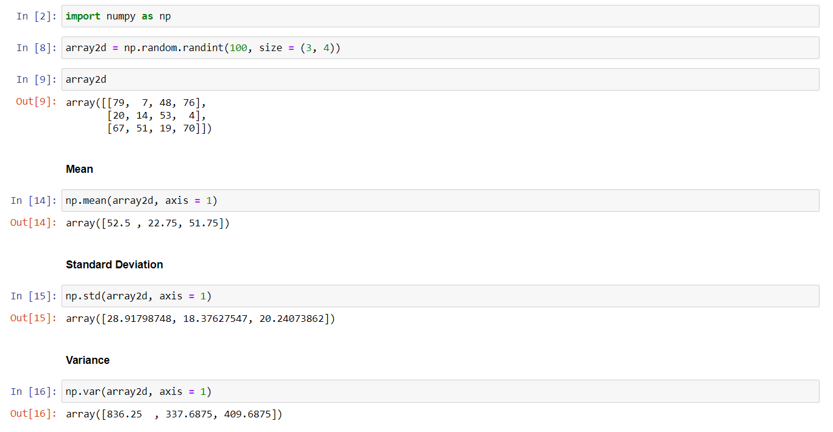

1. **Get the indices of the sorted elements of a given array.**

**B = [56, 48, 22, 41, 78, 91, 24, 46, 8, 33]**

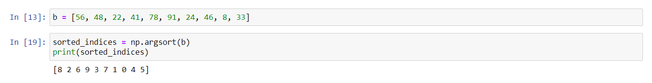

1. **Create a 2-dimensional array of size m X n integer elements, also print the shape, type and data type of the array and then reshape it into n X m array, n and m are user inputs given at the run time.**

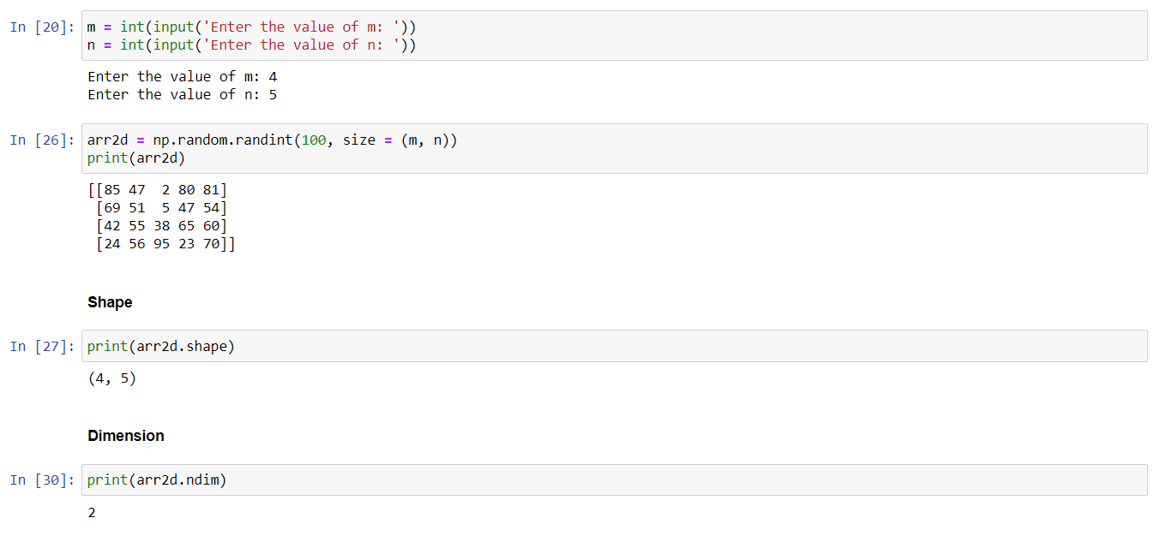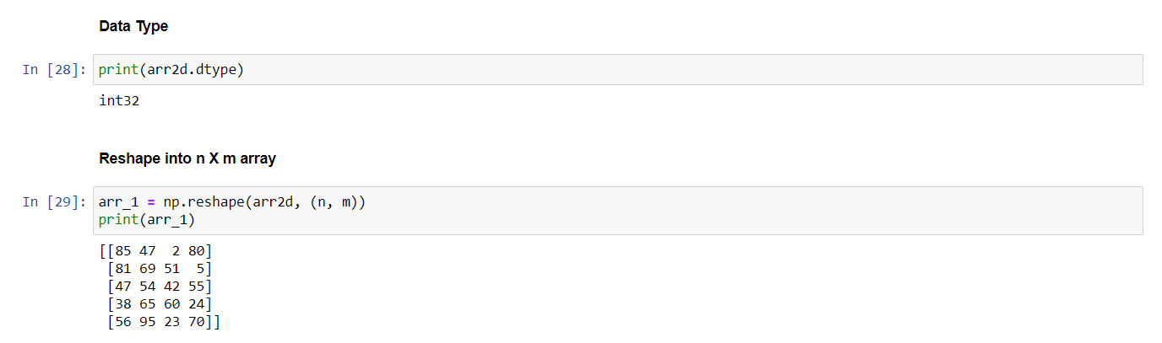

1. **Test whether the elements of a given array are zero, non-zero and NaN. Record the indices of these elements in three separate arrays.**

